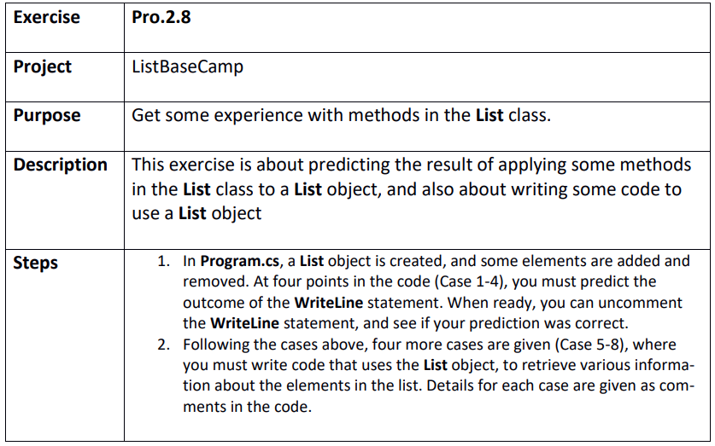

Step 1
ListBaseCamp.sln
Case 1:
Prediction 12
Result 12
Case 2:
Prediction 3
Result 3
Case 3:
Prediction 5
Result 5
Case 4:
Prediction 22
Result 22

Step 2
Case 5:
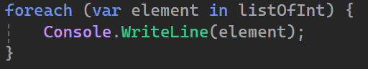
Case 6:
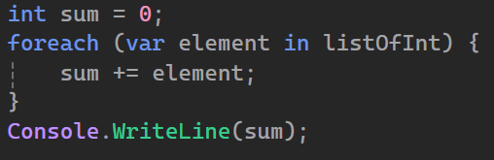
Case 7:
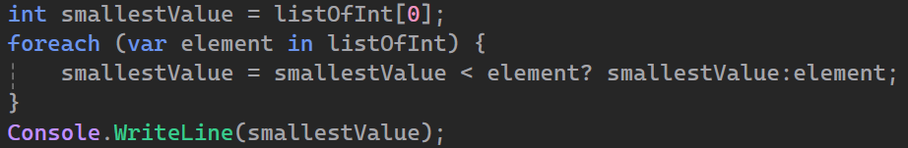
Case 8:
